|  |
| --- |
| University of Suffolk |
| Game Design Document |
| Group 6 |

|  |
| --- |
| By Jack E. Massey S189328 |

Narrative: -



Character: -

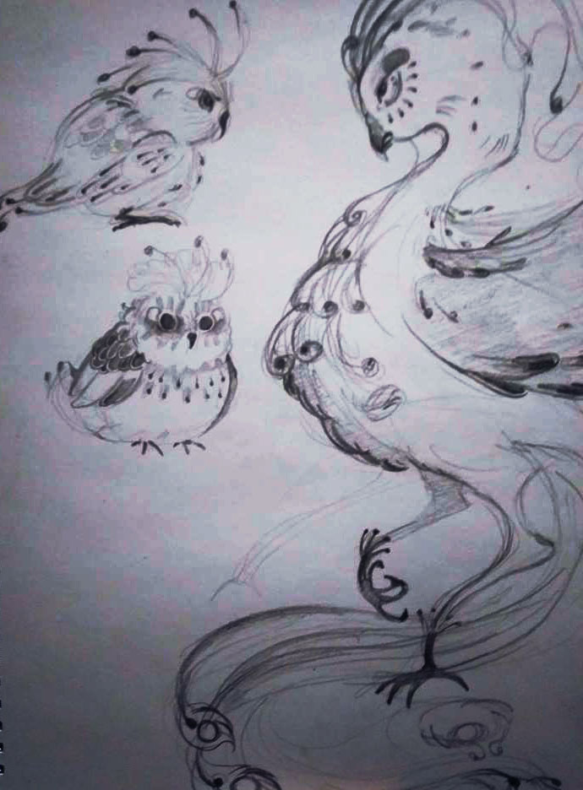

The main character, is designed



Assets: -



Programming: -

